Importance of Physical Activity in Early Childhood Education

Research Summary 16—Fall 2025

Prepared by the Georgia Family Connection Partnership Evaluation, Results, and Accountability Team

The Centers for Disease Control and Prevention recommends that children ages 3 to 5 need to be physically active throughout the day, including aerobic, muscle strengthening, and bone strengthening activities. However, only 24% of children get the recommended daily amount of physical activity (CDC, 2025). Physical activity plays a key role in children’s development across all domains and sets the foundation for long term health and wellness. Including physical activity in early childhood education has multiple benefits for children, families, teachers and communities. With increasing numbers of children in out-of-home care, it is important that early childhood education (ECE) settings include opportunities for physical activity and physical activity education. Over time, early childhood education has shifted more towards academic programming and reducing physical activity. However, research has demonstrated that physical activity is increasingly important for young children in particular and the reduction in physical activity in early childhood has negative impacts on whole child development (Stuart, 2021). Ensuring enough physical activity can have positive impacts on cognitive development, social-emotional development, physical development, and long-term health and well-being. In addition, ensuring enough physical activity opportunities can help with classroom management and reduce stress and well-being for teachers and families. Pfeiffer and Clevenger (2025) focus on the importance of discussing physical activity in early childhood through the socio-ecological model including individual factors (physical ability, genetics, demographics), interpersonal factors (family support and perceptions); organizational level (quality of preschools, available equipment and teachers), community level (safe play spaces), and policy level (policies that promote physical activity in early childhood education.

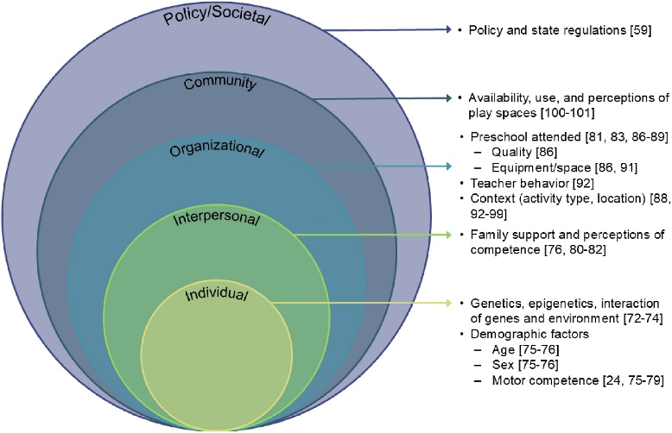

In this research summary and webinar, we will examine research and recommendations regarding the importance of physical activity in early childhood education and the impact on children, classrooms, and families. It will begin with a review of why physical activity in ECE is important to various developmental areas, developmental impact and recommendations by age group, then include a review of ways to incorporate physical activity into classrooms. Finally, it will conclude with recommendations for local collaboratives and communities to support Pre-K programs and families.

Importance of Physical Activity for Child Development
Physical activity throughout the day has been found to have a positive impact on young children’s academic performance, brain development, executive function, school readiness physical development (muscular fitness), heart and lung health, bone strength and cardiometabolic health (CDC, 2025; Stuart, 2021). Physical activity habits begin and are established in early childhood (Crumbley, Ledoux, & Johnston, 2019; Pfeiffer & Clevenger, 2025). In her graduate schoolwork, Gillen (2025) points out that preschool programs rarely have physical activity requirements, however new physical education requirements for Colorado public schools now also include Pre-K. Studies have found that when children are active during early childhood, they are more likely to continue that into adulthood.

Physical development: Physical activity plays a crucial role in physical development for young children, particularly those birth to 5. During this time, children are experiencing significant physical growth and gross and small motor development that physical activity plays a critical role in helping to develop and master (CDC, 2025; Massare & Myers, 2023). It helps build large and fine muscles, strengthens bones and sets the foundation for ensuring bone strength and endurance. It is necessary as children are developing large muscles and improving coordination (Massare & Myers, 2023).

Through structured and organized physical activity, children develop motor skills and develop mastery over fine and gross motor skills, and hand eye coordination (Crumbley, Ledoux, & Johnston, 2019; Massare & Myers, 2023). Structured and organized physical activity with specific rules and methods, guided by a teacher, can help children work on these skills and work toward mastery. By utilizing physical activity that children enjoy, they are more likely to work on these skills and improve development (Crumbley, Ledoux, & Johnston, 2019).

Long-term health outcomes: Ensuring enough physical activity and regular physical activity during young ages can help improve bone density and muscle development. It also reduces the risk of obesity and Type 2 diabetes and helps to maintain normal blood sugar levels (CDC, 2025). Physical activity beginning in early childhood is related to overall physical fitness, mental health, and reduction in chronic disease (Stuart, 2021; Pfeiffer & Cleveland, 2025).

Cognitive development: Structured physical activity can help young children with spatial awareness, executive function and language development. Physical activity plays a critical role in language development and cognitive growth (Pfeiffer & Cleveland, 2025). It can help young children develop literacy connection as language and words can be taught in context with movement activities (like movement games and songs) (Crumbley, Ledoux, & Johnston, 2019; Gillen, 2025).

Stuart (2021) highlights the importance of structural physical activity for brain development by enhancing blood flow and stimulating neurons. These connections are critical for creating and maintaining neural connections. Physical activity improves cognitive performance and larger brain structures. It also supports executive function skills like self-control and cognitive flexibility.

Social-emotional development: Physical activity supports overall emotional well-being and social skill development (Pfeiffer & Cleveland, 2025). Physical activity throughout the day has been shown to reduce depression risk, improve attention and memory capacity in young children (CDC, 2025; Massare & Myers, 2023). Active free play time provides opportunities for children to develop bonds and relationships with peers and teachers. It also provides opportunities to build skills around negotiating, conflict resolution, and shared activities. Through physical play, children build communication skills, learn how to express their needs, and develop leadership skills (Crumbley, Ledoux, & Johnston, 2019; Pfeiffer & Cleveland, 2025). These skills are built through both structured and unstructured physical activity time. Massare and Myers (2023) discuss the importance of physical activity in improving mood and self-esteem among young children. Children are generally able to focus more and are less fidgety when physical activity is integrated throughout the day.

Importance and Recommendations by Age
It is critical for all children in early childhood for physical activity to be integrated throughout the day in a wide variety of ways. Classrooms should include fun physical activity for kids and build upon things that children enjoy so that they want to participate (CDC, 2025). Early childhood education settings are in a unique position to help set the foundation for regular physical activity in young children. Early childhood education classrooms may be the one safe space that children have for physical activity when they do not have the time or space at home (Massare & Myers, 2023). Unfortunately, Mac and colleagues (2021) found that most early childhood educators lack adequate training and resources for implementing structured physical activity sessions, with 70% not fully implementing vigorous activities as planned. Pfeiffer and Clevenger (2025) point out that current data indicates that most preschoolers do not get the recommended physical activity amounts.

Multiple researchers discussed recommended early childhood daily physical activity guidelines from the World Health Organization, the National Association for Sport and Physical Education, and Centers for Disease Control (Stuart, 2021; Pfeiffer & Clevenger, 2025; Massare & Myers, 2023), including:
- Infants need physical activity several times a day throughout the day. This should focus on floor-based play, at least 30 minutes daily of tummy time play, and safe spaces for free open movement not limited to infant play equipment.
- Toddlers need two to three periods of outdoor play time. They also need two or more structured activities that promote movement and gross motor skills (movement songs and games). In addition, daily physical activity should include 60 to 90 minutes of moderate to vigorous activity. Sedentary periods should be limited to an hour at a time.
- Preschoolers need physical activity throughout the day in different lengths of time. Overall, they should have at least 180 minutes of physical activity daily. They should also have at least 2 to 3 outdoor periods each day and two or more periods of structured play activities focused on gross motor skills.
- Six-year-olds need at least 60 minutes of physical activity and should include both structured and unstructured physical activity throughout the day.

Incorporating Physical Activity in Classrooms
Physical activity can also help greatly with classroom management. When children have enough physical activity time and it’s scheduled throughout the day, it can help young children use their energy and increase their ability to focus (Massare & Myers, 2023). There are multiple ways that young children can be engaged in physical activity in developmentally appropriate ways that help them build necessary skills. These include both structured (organized, rule based, planned activities) and unstructured (free play, open activity) (Pfeiffer & Clevenger, 2025; Massare & Myers, 2023). Classrooms should include space and time for both indoor and outdoor physical activity space (CDC, 2025; Massare & Myers, 2023). Taking a multi-strategy approach that includes free-time physical activity and a wide range of structured physical activity time was found to be the most successful in both implementing physical activity into classrooms and in engaging children in physical activity daily (Mac, Chan, & Capio, 2021). Pfeiffer and Clevenger (2025) point out that risky play with elements of challenge and potential injury help children develop motor competence and risk assessment skills. Nature based play enhances emotional and social resilience, promotes creativity, and physical activity overall. Diverse movement types are needed to promote individual development in young children across multiple areas (Pfeiffer & Clevenger, 2025).

By integrating physical activity across all curriculum areas and focusing on mastery, kids were more likely to be active and stay active. Shifting the focus from competition to mastery had positive impacts on children engaging in physical activity during the day (Mac, Chan, & Capio, 2021; Massare & Myers, 2023). Massare and Myers (2023) point out that by incorporating physical activity in the classroom, in physical education instruction, and in organized sports and free activity time, ECE settings can help ensure that young children get the physical activity levels needed throughout the day and build on the key benefits. They also discuss the importance of integrating physical activity in classrooms to help children focus, reduce fidgeting, and promote motivation to learn. It helps children stay on task and focus when used as part of the regular day and not as a punishment or reward (Massare & Myers, 2023).

Further, adults modeling physical activity increases the likelihood of young children being physically active. When teachers engage in play and physical activity with children, they are more likely to participate. This includes both in free time play as well as organized structured physical activity. It is critical that caregivers engage in behaviors as well as give direction to children on how to do the activities (Crumbley, Ledoux, & Johnston, 2019). Teachers can role play physical activity by participating in play time, leading structured activities, and generally demonstrating regular activity (Massare & Myers, 2023).

Fundamental movement games and practice were found to be the most effective at increasing physical activity in early childhood classrooms and teachers reported that this was the best way for them to include activity throughout the day. However, across multiple studies, teachers reported that one of the biggest challenges was time constraints and requirements. Teachers also reported greater levels of comfort with traditional teaching methods over physical activity (Mac, Chan, & Capio, 2021).

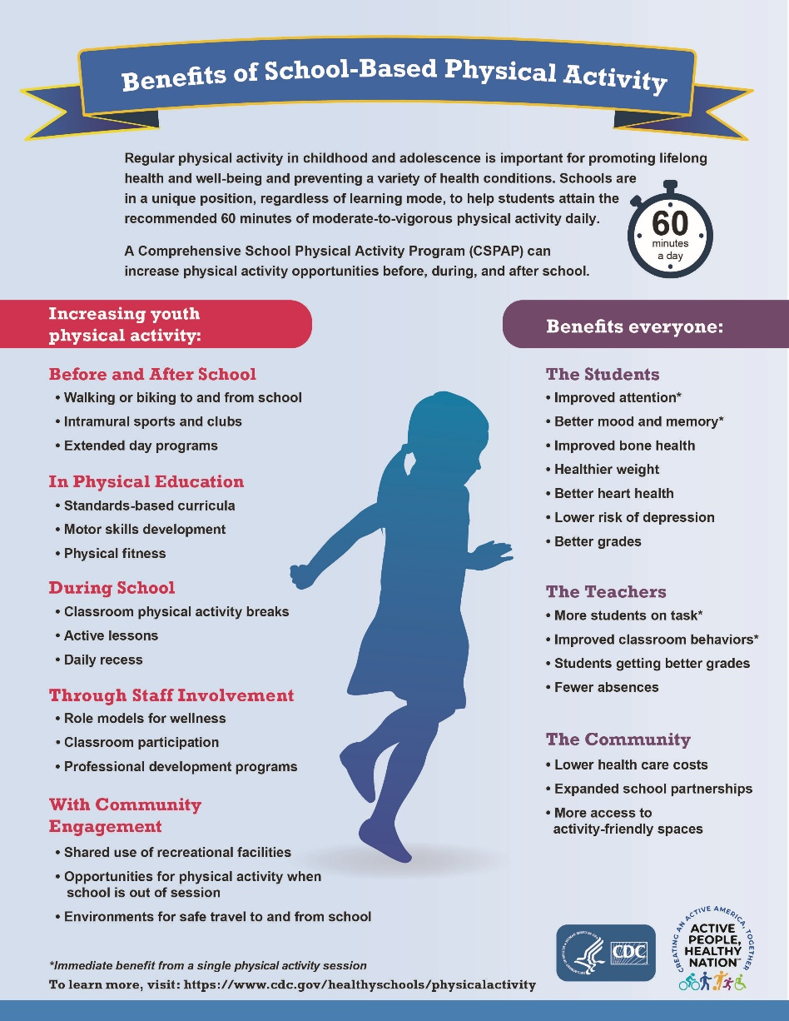

Recommendations for Communities
There are a number of ways that communities can support children, teachers, and early childhood settings in ensuring enough physical activity for young children. Some of these include:
- Supporting training opportunities and professional development opportunities for teachers working with young children (Mac, Chan, & Capio, 2021).
- Holding community events that are targeted toward supporting physical activity for young children and opportunities for adults and children to engage in activities together (Mac, Chan & Capio, 2021).
- Advocating for systemic changes in early education policies and requirements to successfully implement physical activity changes in early childhood education (Mac, Chan, & Capio, 2021).
- Supporting research to address impacts of physical activity on areas like hyperactivity, working memory, and with special populations (Stuart, 2021).
- Supporting data collection and monitoring efforts toward progress on public health goals impacted by early childhood physical activity (Pfeiffer & Clevenger, 2025).
- Finding ways to support families’ regular physical activity through community events (Massare & Myers, 2023).
- Helping ensure safe (lighting, crime, etc.) public places for children to play in the community and in early education settings.
- Ensuring early education settings have the infrastructure and supplies needed to support indoor and outdoor physical activity.

Reference Materials
Centers for Disease Control and Prevention. (2025). Health Benefits of Physical Activity for Children. Available online: cdc.gov/physical-activity-basics/health-benefits/children.html

Crumbley, C. A., Ledoux, T. A., & Johnston, C. A. (2019). Physical Activity During Early Childhood: The importance of Parental Modeling. American Journal of Lifestyle Medicine, 14(1): 32-25. Available online: pmc.ncbi.nlm.nih.gov/articles/PMC6933558/

Gillen, B. (2025). The Impact of Physical Activity in Early Childhood Classrooms. University of Northern Colorado: True North. Available online: unco.edu/news/articles/grad-student-research-julie-bell-2025.aspx

Mac. T. C., Chan, D. K., & Capio C. M. (2021). Strategies for Teachers to Promote Physical Activity in Early Childhood Education Settings – A Scoping Review. International Journal of Environmental Research. Public Health. Promoting Nutrition and Physical Activity in Education and Care Settings. Available online: mdpi.com/1660-4601/18/3/867

Massare, B. & Myers, A. (2023). Physical Activity. Chapter 5. Healthy Young Children. 6th Edition. Available online: naeyc.org/sites/default/files/globally-shared/downloads/PDFs/resources/pubs/healthy-young-children-sixth-edition-chap-5.pdf

Pfeiffer, K. A., & Clevenger, K. A. (2025). Importance, unique aspects and guidelines, and building blocks of early childhood physical activity from a socioecological perspective. Sports Medicine and Health Science, 7 (5), 308-316.

Stuart, K. (2021). The Importance of Physical Activity in Early Childhood Development. Northwestern College, Iowa, NWCommons. Master’s Theses and Capstone Projects. Available online: nwcommons.nwciowa.edu/education_masters/304/

